Batman’s adventures
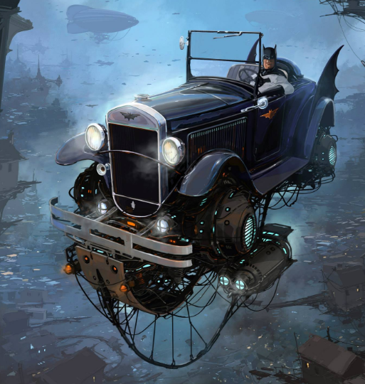

Look carefully at the picture of Batman above. What do you notice? What can you see? There are a number of writing opportunities to complete, the children may choose which activities they want to complete in any order. Please see the corresponding resources to support the children with these activities. Don’t forget to share your amazing work on Class Dojo!
Task | Completed ✔ | How do you think it went?
- Write down 5 -ing verbs from the picture. Put one of them into a sentence.

- Write some sentences about this picture – are they statements, questions, exclamations or commands? How do you know?

- Create a comic strip which includes this image. What happens before and after this picture?

- What is special about Batman’s car? Why does his car need these features? Use subordinate conjunctions (because, if, so, that, when) to explain why the features are necessary.

- Where is this car going? Can you write a story describing Batman’s adventure?

