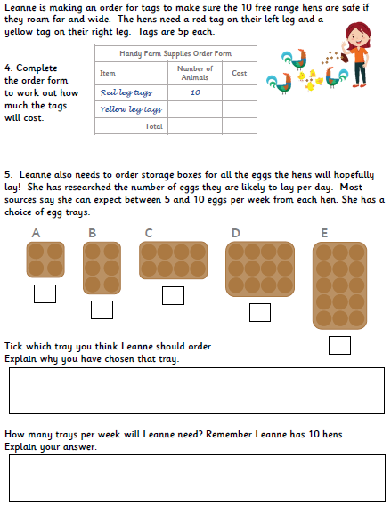

**Task 2: Can you complete the division problem solving tasks?**