1 | 2 | 3 | 4 | 5 | 6 | 7 | 8 | 9 | 10 | 11 | 12 | 13 | 14 | 15 | 16 | 17 | 18 | 19 | 20
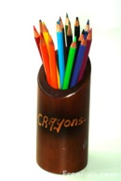
Tom has 11 pencils. Ben has 14 pencils. How many more pencils does Ben have than Tom?
Nina has 8 sweets and Lily has 12. How many more does Lily have than Nina?

Paul and Louise have 3 pets and Charlie and Harry have 7. How many more pets do Charlie and Harry have?
Adam has 7 Transformers. Lewis has 13. How many fewer does Adam have than Lewis?
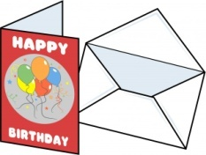
Katy has 17 birthday cards and Laura has 13. How many fewer does Laura have than Katy?
Amy buys a Minion for £9. It was £16. By how much has the price been reduced?

