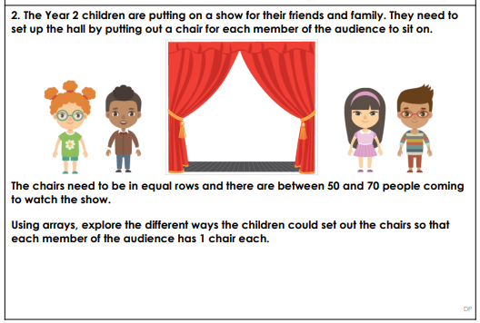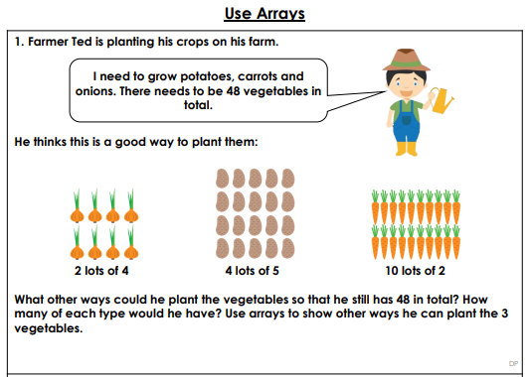

Task 2: Can you discuss the problems below with a family member and work out the possible answers using arrays?