British Wildlife
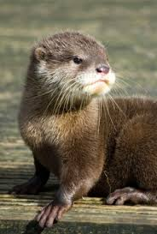
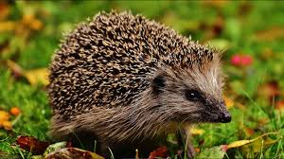
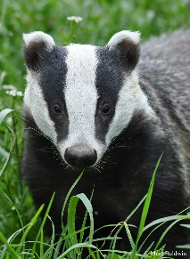
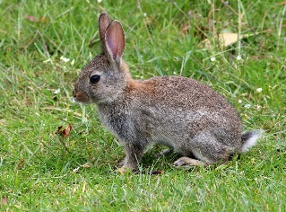
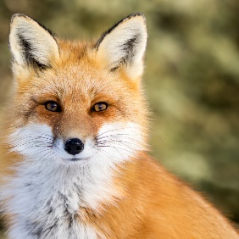

This week in English, we are linking into our topic work and thinking about British wildlife. We will be looking at non-fiction writing and asking the children to carry out some research about their class animal, along with a variety of other writing opportunities.
Task | Completed ✔ | How do you think it went?
- What is your class animal? Why are you proud to be a ________? What qualities do you bring to your class? Why are you a good member of ____ class? Use subordinate conjunctions to explain.
- Can you write a list of questions that you would like to know about your class animal?
- Research 5 interesting facts about your class animal and present it as factual poster.
- Label the features of your class animal using expanded noun phrases. E.g. sharp, pointy claws.
- Create a repeated pattern using all 5 class animal tracks. Explain how you have created your track pattern using ‘and’ to join your ideas.

Please see the corresponding resources to support the children with these activities.

Don’t forget to share your amazing work on Class Dojo!

