The Enchanted Kingdom
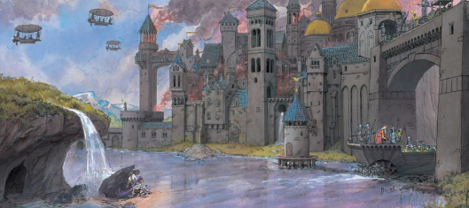
The Enchanted Kingdom Tasks
Look carefully at the image of the Enchanted Kingdom above. What can you see?
There are a number of writing opportunities to complete, the children may choose which activities they want to complete in any order. Please see the corresponding resources to support the children with these activities. Don’t forget to share your amazing work on Class Dojo!
Task | Completed ✔ | How do you think it went?
- Imagine you are one of the children in this picture. Use your five senses to describe what you can see, hear, smell and touch in this place.

- Where is this castle and river? Can you draw a map of this place and label the features?

- Why are the children and the purple bird hiding behind the rock? What is going to happen next? Write a paragraph to explain using conjunctions.

- Why are some of the buildings on fire? What questions could you ask to find out more information about the fire?

- Can you design a fire safety poster to remind your family how to stay safe around fire?

