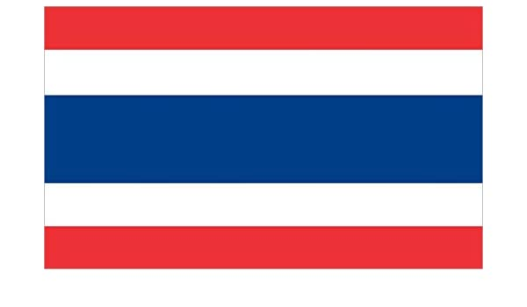
Traditional Thai Folk Story
This traditional Thai story is about four princes from the ancient city of Ayutthaya (prounounced A-yoo-ta-ya).
The city is 80km north of Bangkok, can you find out any interesting facts about it?

The Red Bud Tree
Once upon a time, a wise and brave king ruled the city of Ayutthaya. He had four young princes. The young princes had grown up hearing many wonderful stories about a beautiful tree known as the Red Bud Tree. They had never seen the Red Bud tree but they all wanted to be the first to see it.
One day, the eldest prince asked the king’s driver to take him deep into the woods where this tree grew. It was still early spring and the tree was standing as a bare stump of wood in the forest, without any leaves or buds. The prince was disappointed and didn’t understand why it was known as the Red-Bud tree, so he returned to the palace.
Sometime later in spring, the next son asked the king’s driver to take him to the Red Bud Tree. By this time, the tree was covered with bright red buds and looked very beautiful. The young prince was very pleased.
The third son went into the woods just after the spring time. Now tree did not have any red buds and was covered with lush, green leaves. He also didn’t understand why it was called the Red Bud tree.
The youngest prince also decided to go and have a look at the famous Red Bud tree. By this time, the tree was covered with little bean-pods. When he came back from the forest, he ran into the garden where his brothers were playing and told them with much excitement, "I saw the Red Bud tree!"
"So what? There is nothing special about it" said the eldest prince. “It is nothing but a dead stump of wood,” He added grumpily.
"What makes you say that?" said the second son. "When I went into the woods, it was covered with hundreds of beautiful, red buds. This is why it is known as the Red Bud tree." The third prince said, "I have also seen the Red Bud tree. It is neither a dead stump of wood nor covered with red buds. It looks like an ordinary tree covered with green leaves." The youngest prince confidently said, "Brothers, all of you are mistaken! I have just seen the tree and I can say for sure that it is now covered with little bean-pods."
The princes thought that maybe the Red Bud tree was a mysterious, magical tree and it appeared in different forms for different people. The King was sitting in the garden and listening to the princes talk, but he didn’t say anything. He simply sat back, smiled to himself and chuckled quietly.
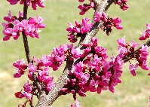
Traditional Thai Folk Story – The Red Bud Tree

Questions

Remember to try and answer the questions in full sentences. You will find some of the answers to these question within the text and others you will have to think a little more deeply. Have a go!

- Can you find a word in the text that means the same as crossly or grouchily?
________________________________________________________________________________

- How many princes did the King have?
________________________________________________________________________________

- Can you find a question in the text? How do you know it is a question?
________________________________________________________________________________________________________________________________________________________________

- Why was the eldest prince disappointed when he went into the woods?
________________________________________________________________________________________________________________________________________________________________

- Do you think the Red Bud tree was really mysterious and magical? Why?
________________________________________________________________________________________________________________________________________________________________

- Why did the King smile to himself and chuckle quietly?
________________________________________________________________________________________________________________________________________________________________

