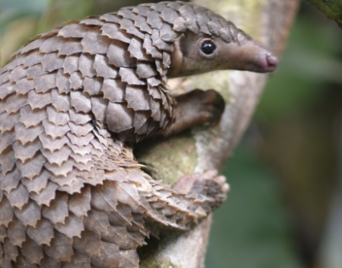
The Pangolin and the Hedgehog

This week in English, we are continuing to think about wildlife and linking it in with our topic work all about animals from Thailand. We will be looking at non-fiction writing and asking the children to carry out some research about the Pangolin, along with a variety of other writing opportunities. Please watch the short animated film with your child and see the corresponding activities.
https://www.skwigly.co.uk/showcase/the-pangolin-and-the-hedgehog/
Task | Completed ✔ | How do you think it went?
- What types of animal is a pangolin? Does this surprise you? Why/why not? Explain using subordinating conjunctions (e.g. because) using your topic work from last week to help you.
- Describe the differences and similarities between the hedgehog and the pangolin using suffixes (-est, -er).
- What happened to the pangolin’s mum? Do you think it is right for humans to capture animals in this way? Explain using ‘because’.
- Create a poster all about pangolins. Include their habitat, diet, appearance and some interesting facts.
- Can you create your own stop motion film in the style of this video?
Use this website to help you:
https://www.bbc.co.uk/teach/class-clips-video/art-and-design-ks2-stop-motion-animation/zr67kmn
and this app:
PicPac Stop Motion & TimeLapse

Please see the corresponding resources to support the children with these activities.

Don’t forget to share your amazing work on Class Dojo!

