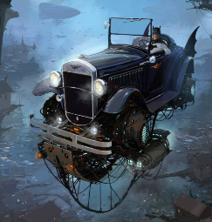
Batman’s Adventure
English – Activity 5

________________________________________________________________________________________________________________________________________________________________________________________________________________________________________________________________________________________________________________________________________________________________________________________________________________________________________________________________________________________________________________________________________________________________________________________________________________________________________________________________________________________________________________________________________________

_____________________________________________________________________________________________________________________________________________________________________________________________________________________________________________________________________________________________________________________________________________________________________________________________________________________________________________________________________________________________________________________________________________________________________________________________________________________________________________________________________________________________________________________________________________________________________________________________

