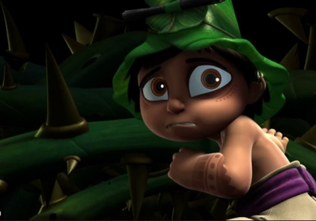
The Catch
This week we are going to be watching a short film about a young boy who finds a friend in an unexpected place. Please see the link here to view the video.
https://www.youtube.com/watch?v=iOABzu9hH2A

There are a number of different activities to complete, the children may choose which activities they want to complete in any order. Please see the corresponding resources to support the children with these activities. Don’t forget to share your amazing work on Class Dojo!

Task | Completed ✔ | How do you think it went?
- Look at the pictures from the film carefully. Can you write a sentence about each of them?
Remember your capital letters and full stops and try to include some fantastic adjectives!
- Watch the video carefully. Can you draw a map of the things the boy sees on his way from the pond to the huge lake? Don’t forget to label your map (e.g. spiky thorns, long, hollow log, etc.). Can you write a description of the boy’s journey?
- Design your own fish for the end of the story. You can use one of the templates or make your own fish. Don’t forget to label it to explain each part of your fantastic fish!
- How much do you know about fish? Could you write a fishy fact file? See if you can research what fish eat, where they live and any other interesting facts.
- Can you create a fishy story of your own? You can write it, film it, make a puppet show or think of another creative way to tell your story.

