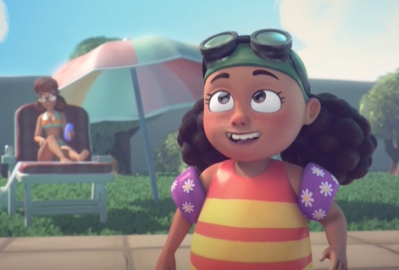
Belly Flop!
This week we are going to be watching a short film about a young girl who becomes an unlikely hero. Please see the link here to view the video: https://www.youtube.com/watch?v=ls5J7caQj7A&feature=youtu.be&safe=active
There are a number of writing opportunities to complete, the children may choose which activities they want to complete in any order. Please see the corresponding resources to support the children with these activities. Don’t forget to share your amazing work on Class Dojo!

Task | Completed ✔ | How do you think it went?
- The young girl is scared before she dives off the highest diving board. Imagine you were her friend. Write down sentences to encourage her to be brave. Make sure you use capital letters and full stops!
- Can you write a list of all the hazards that you can see in the video. Make a safety poster that the lifeguards could use around the pool.
- The young girl is an unlikely hero at the end of the video. Take some time to reflect, when have you been an unlikely hero and helped somebody else? Write down three super sentences.
- Describe the water using your five senses. What do you think it would smell, look and feel like?
- Can you use construction materials like Lego to build your own Lido? Ask an adult to record a video of you sharing a tour of your Lido and upload it to your Class Dojo portfolio.

