Literacy - Activity 2

Write some sentences about this picture.
Can you write a statement, command, question and an exclamation? Make sure you use the correct punctuation for each sentence type!
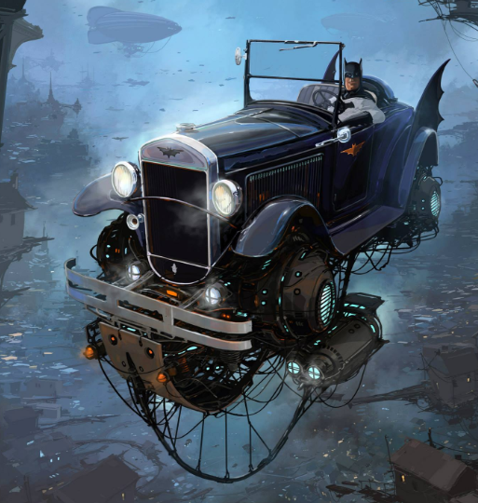
Statement: contains a fact, opinion or idea, e.g. Tigers are mammals.
Command: contains a ‘bossy’ imperative verb, e.g. Peel the potatoes.
Question: asks a direct question and ends in a question mark, e.g. Where are you going?
Exclamation: expresses a strong emotion and ends in an exclamation mark, e.g. What a great day it is!

____________________________________________________________________________________________________________________________________________________________________________________________________________________________________________________________________________________________________________________________________________________________________________________________________________________________________________________________________________________________________________________

