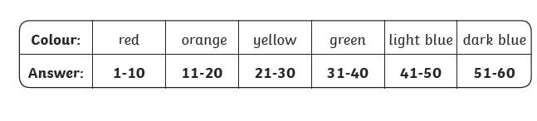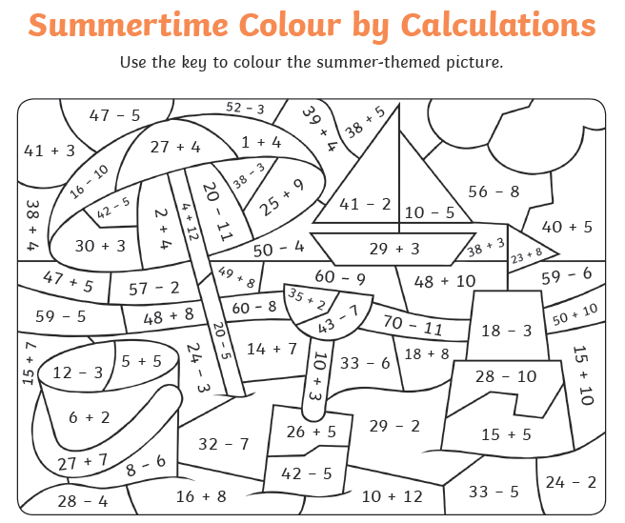

Task: Can you calculate the answers to the number sums and use the key to colour it in?