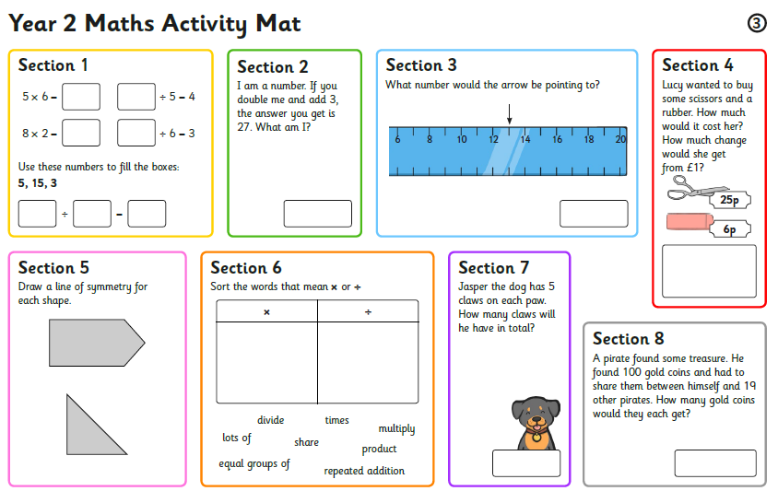

Task 3: Can you work out the answers to each question?