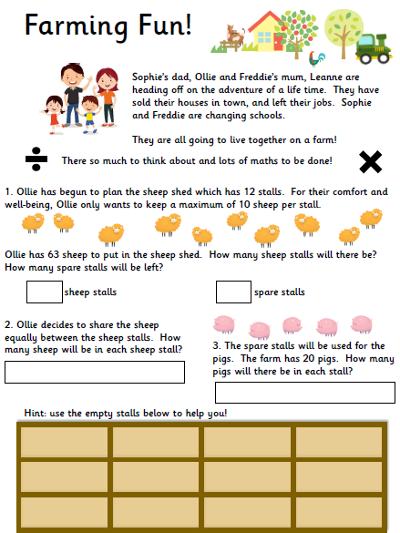

**Task 1: Can you complete the division problem solving tasks?**