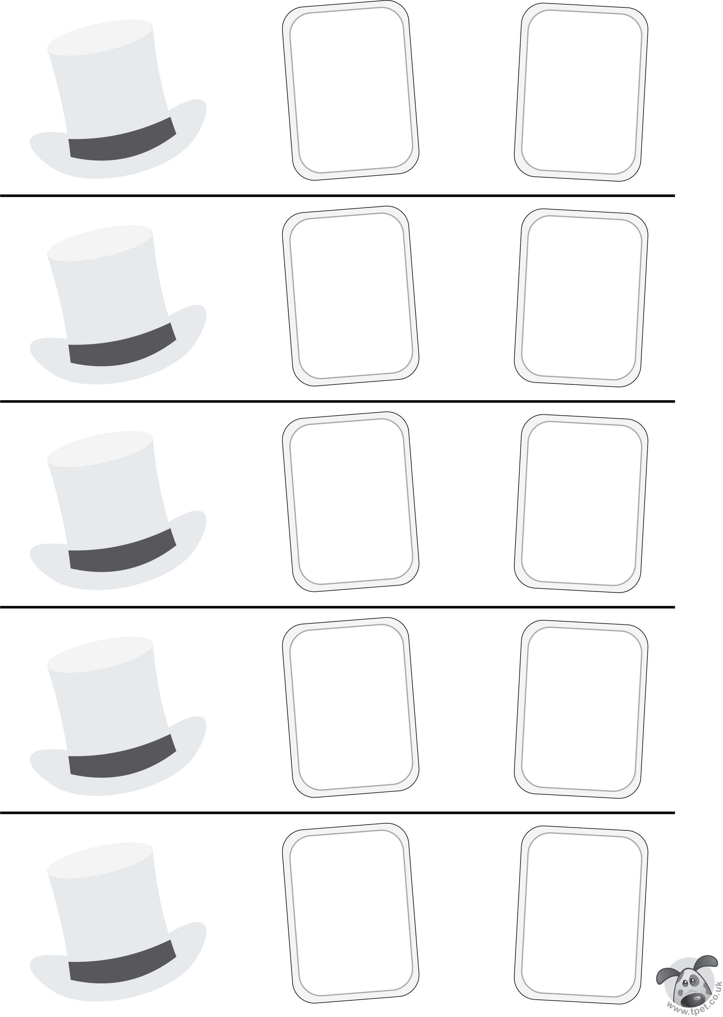

**46**

**33**

**89**

**24**

**58**

Partition each 2-digit number into multiples of ten and one.