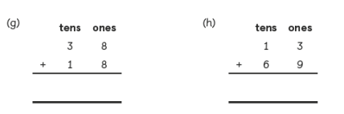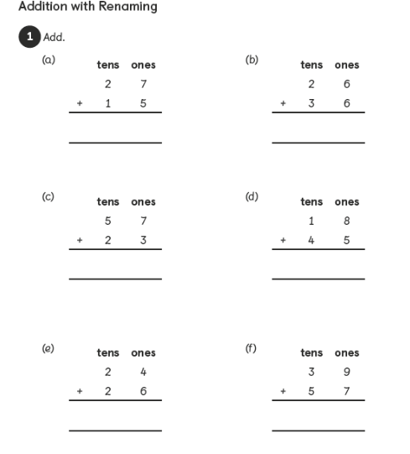

Task: Can you add 2-digit numbers to a 2-digit number resulting in renaming of ones.