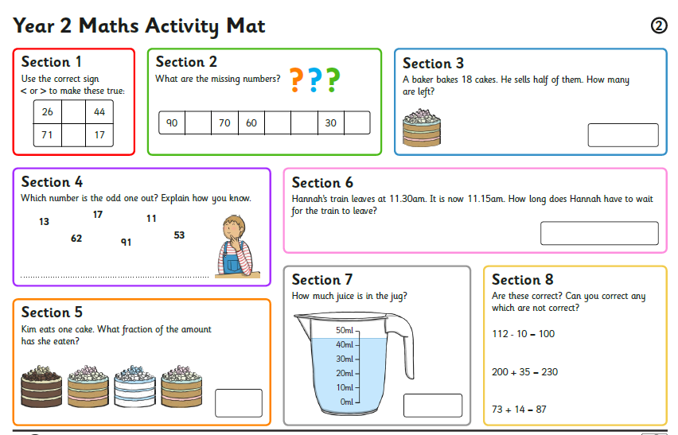

Task 2: Can you work out the answers to each question?