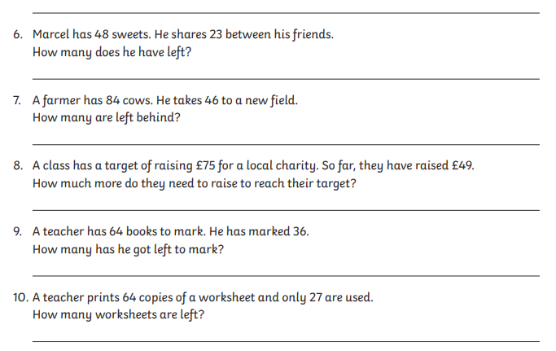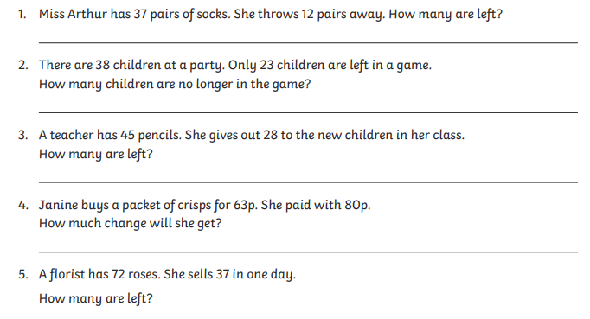

Task 1: Can you solve the subtraction word problems? Don’t forget to show your working out.