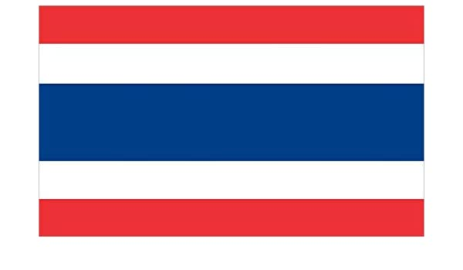
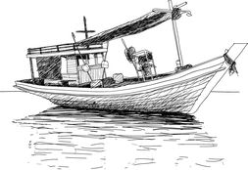
Traditional Thai Folk Story
Before you read the folk story, can you find Thailand on a map?
Look at its long coastline, what do you think people like to eat?

Ta-in and Ta-na
Once upon a time there were two men who lived in a coastal village in Thailand. One was named Ta-in and the other was named Ta-na. They were good friends and liked to do things together. Ta-in and Ta-na were very good fishermen so they decided to fish together in the bay. They built a small boat and caught lots of fish. They shared their catches and cooked them for their dinner. However, after many months their luck changed and they started to catch less and less fish.
One day the two men had tried everywhere they knew to find some fish but had no luck. Finally, Ta-in caught one fish and brought it home. Since Ta-na had not caught a fish, his friend said that he would give him the tail part of the fish and take the head and middle part for himself. Ta-na did not like this at all. He also wanted the head and middle of the fish. Ta-in did not agree and cried “That is not fair! I am the real owner of the fish because I caught it! I deserve the head and middle, and you should be happy to take the tail”. They could not agree. They became angrier and angrier and started to push and yell at each other.
A village elder called Ta-yoo came by and heard them fighting. He pulled the men apart saying, “Stop fighting!” Ta-in and Ta-na calmed down and agreed to let the elder solve their problem. Ta-yoo thought about the problem for a long time.
Finally, he spoke. “Ta-in, you caught the fish so you can take the head. Ta-na, you did not catch any fish so you can take the tail part. I have had to solve the problem for you so I will take the middle part of the fish”.
The two men were shocked but could not think of any other way, so they agreed. Ta-in then took the head, Ta-na took the tail part and Ta-yoo took the biggest and best part of the fish.
Both Ta-in and Ta-na were very sad. “How foolish we were”, said Ta-in. “I caught the fish, and Ta-yoo got the best part. I should not have been so selfish”. “No, I was the selfish one”, said Ta-na. “I didn't catch a fish, so I should have been happy to take the tail part”. The two men looked at each other. They finally realised that they had both been greedy. Because of this, they were both losers that day, but they had learnt a valuable lesson.

From that day on, they worked together and helped one another. They shared their catches, no matter who had caught the most fish. In time the fish returned again in great numbers, and Ta-in and Ta-na caught so many fish that they could sell most of them. They even paid other men to help them with their fishing. They not only had become good friends again, they had also become wealthy.
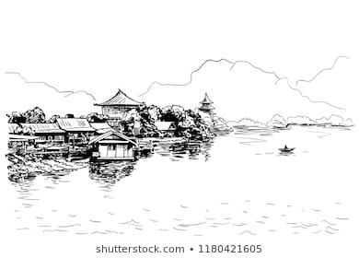
Traditional Thai Folk Story – Ta-in and Ta-na

Questions

Remember to try and answer the questions in full sentences. Many of these questions need you to think a little deeper, infer meaning and use your own experiences to answer them. Have a go!

- Find a word in the story that means the same as ‘shout’.
_____________________________________________________________________________

- Ta-yoo plays the elder in this story. He solves the problem that the two men were having. What might have happened if Ta-yoo had not arrived?
__________________________________________________________________________________________________________________________________________________________

- Why do you think that the elder Ta-yoo took the best part of the fish for himself?
__________________________________________________________________________________________________________________________________________________________

- Why did Ta-in and Ta-na accept his decision? Can you think of anyone that resolves problems like this in your life?
_______________________________________________________________________________________________________________________________________________________________________________________________________________________________________

- What did Ta-in and Ta-na learn from their experience? What is the moral of this story?
_______________________________________________________________________________________________________________________________________________________________________________________________________________________________________

- Can you think of any times that you have had to learn a similar lesson?
_______________________________________________________________________________________________________________________________________________________________________________________________________________________________________

