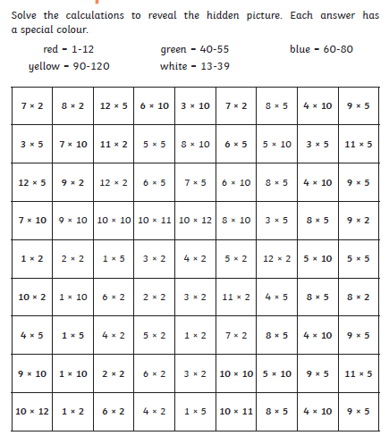

Task: Can you calculate the answers to the multiplication sums and reveal the mosaic pattern?