Paradise Island
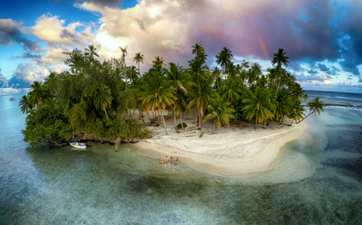

The trees, which stretched up far from the sandy shoreline, covered almost all of the small island. We sat there quietly, taking in the natural beauty that surrounded us. Finally, we had made it to paradise, our home for the next two months. At that moment, as a faint rainbow painted the sky with colour, I felt a sense of anticipation about our time on the island. ‘How will you cope without your TV?’, ‘What will you do for food?’, ‘Won’t you be scared?’ my family had asked. I didn’t have answers to their questions but as the sun began to break through the clouds, I knew that the months ahead would be full of challenges and excitement…

Paradise Island tasks
Task | Completed ✔ | How do you think it went?
- Who is telling the story? Who are they with? Why have the people arrived on the island for two months? Can you write a story setting the scene.

- If you had the chance to go on an island adventure and could only take 3 things, what would you take? Who would you choose to go with you and why? Can you use subordinate conjunctions to explain your answers (because, so, if, that, when)?

- Where do you think this island might be? Can you write a descriptive paragraph about where it is located?

- These sentences are sick and need your help to get better. We got to the island. We saw the trees and the beach. And we sat on the beach. I was excited.

- What do you think the view looks like for the people sitting on the beach? Can you draw and describe what you think they are looking at?

Please see the corresponding resources to support the children with these activities.
Don’t forget to share your amazing work on Class Dojo!

