Literacy - Activity 1

Who is telling the story? Who are they with? Why have the people arrived on the island for two months?

Can you write a descriptive setting for the story?

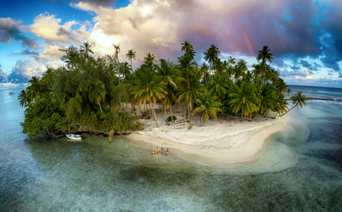

__________________________________________________________________________________________________________________________________________________________________________________________________________________________________________________________________________________________________________________________________________________________________________________________________________________________________________________________________
Key words:
beautiful calm giant crystal turquoise quiet dangerous lovely
unsettling wild scorching freezing windy magnificent lonely
__________________________________________________

