Design and Technology at Round Hill

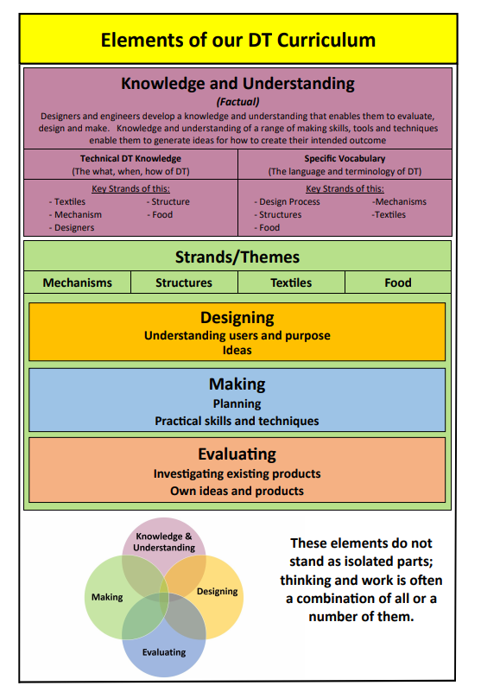

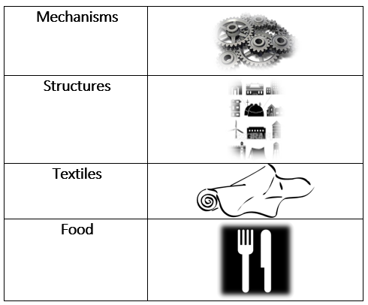

|  |  |  |  |  |  |  |
| --- | --- | --- | --- | --- | --- | --- |
| D&T Overview |  | | | | | |
| **Autumn Term** | | **Spring Term** | | **Summer Term** | |
|  | | | | | |
| **Year**  **1 & 2**  **Cycle A** | Autumn 1. | Autumn 2. | Spring 1. | Spring 2. | Summer 1. | Summer 2. |
| Stock Illustration - Generic structure icons. Clipart Drawing gg53863112 -  GoGraph  **Playgrounds** | **Fabric Roll Clip Art at Clker.com - vector clip art online, royalty free &  public domainPuppets**    **Moving Christmas card** |  |  |  |  |
| **Year**  **1 & 2**  **Cycle** B | Autumn 1. | Autumn 2. | Spring 1. | Spring 2. | Summer 1. | Summer 2. |
|  | **Moving Christmas card** |  | **Moving picture** |  | universal symbol for food - Clip Art Library  **Fruit kebabs** |
| **Year**  **3 & 4**  **Cycle A** | Autumn 1. | Autumn 2. | Spring 1. | Spring 2. | Summer 1. | Summer 2. |
|  | **Egyptian Shaduf**    **Moving Christmas card** |  | universal symbol for food - Clip Art Library  **Seasonal soup** |  | Fabric Roll Clip Art at Clker.com - vector clip art online, royalty free &  public domain  **Pencil case** |
| **Year**  **3 & 4**  **Cycle B** | Autumn 1. | Autumn 2. | Spring 1. | Spring 2. | Summer 1. | Summer 2. |
|  |  | **Roman toy** | **Moving character** |  | Stock Illustration - Generic structure icons. Clipart Drawing gg53863112 -  GoGraph  **Packaging** |
| **Year**  **5 & 6**  **Cycle A** | Autumn 1. | Autumn 2. | Spring 1. | Spring 2. | Summer 1. | Summer 2. |
|  | **Light up Christmas card** |  | **Stock Illustration - Generic structure icons. Clipart Drawing gg53863112 -  GoGraphPlayground shelter** |  | Fabric Roll Clip Art at Clker.com - vector clip art online, royalty free &  public domain  **Bag with fastening** |
| **Year**  **5 & 6**  **Cycle B** | Autumn 1. | Autumn 2. | Spring 1. | Spring 2. | Summer 1. | Summer 2. |
|  | **Fairground ride** |  |  | universal symbol for food - Clip Art Library  **Fairtrade cookies** |  |

Questions

Enquiry Questions

|  |  |  |  |  |  |  |
| --- | --- | --- | --- | --- | --- | --- |
|  |  | | | | | |
| **Autumn Term** | | **Spring Term** | | **Summer Term** | |
|  | | | | | |
| **Year**  **1 & 2**  **Cycle A** | Autumn 1. | Autumn 2. | Spring 1. | Spring 2. | Summer 1. | Summer 2. |
| *How can we design & make a freestanding playground structure that is strong and stable?* | *-How can we join fabric together to make a 3D puppet?*  *-How can we make a moving card using sliders or levers?* |  |  |  |  |
| **Year**  **1 & 2**  **Cycle** B | Autumn 1. | Autumn 2. | Spring 1. | Spring 2. | Summer 1. | Summer 2. |
|  | *How can we make a moving card using sliders or levers?* |  | *How can we design & make a moving picture using wheels & axels?* |  | *How can we chop, peel or grate fruit to prepare a fruit kebab safely and hygienically?* |
| **Year**  **3 & 4**  **Cycle A** | Autumn 1. | Autumn 2. | Spring 1. | Spring 2. | Summer 1. | Summer 2. |
|  | *-How can we use a pulley system to make an Egpytian shaduf?*  *-How can we make a moving card using levers and linkages?* |  | *How can we chop, peel, grate or slice ingredients and adapt recipes to prepare a soup safely and hygienically?* |  | *How can we design & make a fabric pencil case that looks good & is useful?* |
| **Year**  **3 & 4**  **Cycle B** | Autumn 1. | Autumn 2. | Spring 1. | Spring 2. | Summer 1. | Summer 2. |
|  |  | *How can we use cams to make a moving Roman toy?* | *How can we use a pneumatic system to make a character move?* |  | *How can we use a strong, stiff shell structure as packaging to protect biscuits?* |
| **Year**  **5 & 6**  **Cycle A** | Autumn 1. | Autumn 2. | Spring 1. | Spring 2. | Summer 1. | Summer 2. |
|  | *How can we make a light up Christmas card?* |  | *How can we use triangulation & cross beams to strengthen a 3D model?* |  | *How can we design & make a bag that looks good & fastens?* |
| **Year**  **5 & 6**  **Cycle B** | Autumn 1. | Autumn 2. | Spring 1. | Spring 2. | Summer 1. | Summer 2. |
|  | *How can we use an electric motor to design & make a rotating fairground model?* |  |  | *How can we use fairtrade ingredients to prepare and bake cookies safely and hygienically?* |  |