# Round Hill Primary School



“Dream, believe, achieve together.”

**English as an Additional Language (EAL) Policy**

Revised November 2022

Signed by ……………………………… Head Teacher Date…………

Approved by………………………………… Governor Date…………

**Purpose and Rationale**

This policy sets out the school’s aims, objectives and strategies with regard to meeting the needs and celebrating the skills of EAL pupils, and helping them to achieve the highest possible standards. The purpose of this policy is to outline the school’s approach to identification and meeting the needs of pupils who are classified as having English as an additional language (EAL).

At the time of writing this policy there are 34% of EAL pupils in our pupil population. This is much higher compared to the national average of 21%. Our numbers of EAL pupils have increased over the last five years. We are incredibly proud and take every opportunity to celebrate our multicultural and diverse community. At Round Hill we have a transient pupil population due to the proximity to the University of Nottingham and the hospital. Many EAL pupils who start at Round Hill as a mid-phase admission to school. Please see the mid-phase admissions information below.

[Ofsted (2018) feedback](https://www.roundhill.notts.sch.uk/attachments/download.asp?file=393&type=pdf) recommended that Round Hill continued **“to adapt the support that they provide for pupils who have recently arrived at the school who speak English as an additional language, so that these pupils make rapid progress, particularly in developing their language skills.”**

At Round Hill we have used this feedback and worked hard to use an assessment system to support staff with developing the children’s English language acquisition. Teachers use the assessment system for children who are working *below age related expectations* or whose *language is a concern*. Teachers are provided with time during a staff training session to assess the children at three assessment points in each term of the school year. The assessment system we use at Round Hill is the [EAL assessment framework for primary schools](https://www.em-edsupport.org.uk/Pages/Download/a9b6d6da-c524-4f10-8471-a43296aced1b/PageSectionDocuments) created by the Nottinghamshire County Council Achievement and Equality team. Please see the assessment section for more information below.

**Definitions**

In defining EAL we have adopted the following definition:

An EAL pupil is a pupil whose first language is not English. This encompasses pupils who are fully bilingual and all those at different stages of learning English.

EAL pupils may be:

* Newly arrived from another country and school;
* Newly arrived from another country, but an English speaking school;
* Born abroad, but moved to the UK at some point before starting school; o
* Born in the UK, but in a family where the main language is not English.
* EAL pupils will need varying levels of provision.

**Objectives**

* To give all pupils the opportunity to overcome any barrier to learning.
* To welcome and value the cultural, linguistic and educational experiences that pupils with EAL bring to the School whenever possible.
* To implement appropriate strategies to ensure that EAL pupils are supported in accessing the full curriculum.
* To help EAL pupils to become confident and fluent in speaking and listening, reading and writing in English in order to be able to fulfil their potential.
* To encourage children to practise and extend their use of English.
* To encourage and enable parental support in improving children’s language skills.
* To maintain pupils’ self-esteem and confidence by acknowledging and giving status to their skills in their own languages.
* To be able to assess the skills and needs of pupils with EAL and to give appropriate provision throughout the school.
* To equip teachers with the knowledge, skills and resources to be able to support and monitor pupils with EAL.
* To monitor pupils’ progress regularly with a particular focus on the termly data input and pupil progress meetings. Use these to make decisions about classroom management, curriculum planning and appropriate interventions.

**Our Ethos and Values** – also available on the [school website](https://www.roundhill.notts.sch.uk/page/?title=Ethos+%26amp%3B+Values&pid=235)

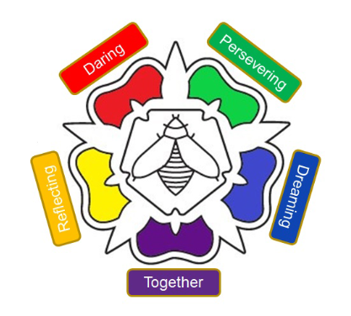

**Vision Statement:** “Dream, believe, achieve together.”

**Mission Statement:** We are a school where we strive for everyone to be valued, appreciated, who can grow in self-confidence, are pleased to be themselves and welcome each other as unique individuals. We are a school that is excited and passionate about learning and developing, we learn from our mistakes, we are resilient whatever is thrown at us and we each have the opportunity to achieve our full potential.

Our five core values and mission statements are:

**Reflecting**

“We learn from our mistakes.”

At Round Hill, we take control of our learning. We reflect on our success and look for exciting new ways to improve. We embrace the importance of making mistakes as part of the learning journey. We adopt a Growth Mindset in our learning and believe in our ability to improve over time.

**Daring**

“We are unique.”

We encourage all members of our community to be proud of what makes them unique and empower them to explore new solutions to challenges. We encourage our staff to explore varied teaching methods and strategies to support all pupils to succeed.

**Persevering**

“We keep trying, no matter what.”

We thrive when presented with a new challenge. We recognise challenges as a new opportunity to learn and better ourselves. We listen to our peers and value feedback because it supports our growth. We recognise challenge as an exciting part of the learning journey and show resilience when we are searching for a solution.

**Together**

“Together Everyone Achieves More.”

We are part of a TEAM where we achieve more by working together.

**Dreaming**

“We aim high.”

We love learning; we recognise that we can all learn and that none of us have stopped developing and learning.

**Teaching and Learning**

Our school seeks to ensure that all pupils are enabled to have access to a broad, balanced and relevant curriculum. English is best learnt through the curriculum and EAL pupils should be encouraged to play a full part in all learning opportunities.

EAL learners make the best progress within a whole school context, where pupils are educated with their peers.

The school structure, pastoral care and overall ethos aim to help EAL pupils integrate into the school whilst valuing diversity.

* Classrooms are to be arranged to be socially and culturally inclusive;
* Teachers recognise the pupil’s mother tongue, identifying their strengths and boosting the individual’s self-esteem, and enabling the pupil to become a bi-lingual;
* Staff acknowledges the time it takes to become fluent in an additional language, with a good command of the range of language needed for successful learning and participation in the class;
* We also recognise that support may be necessary beyond the time a pupil appears orally fluent.

Staff can help pupils learning English as an additional language in a variety of ways:

* By planning differentiated work for EAL pupils if necessary.
* By using a variety of support resources appropriate to the child’s age and level of language acquisition.
* By setting appropriate expectations according to the child’s level of language acquisition.
* By monitoring progress carefully and ensuring that EAL pupils are set appropriate and challenging learning objectives.
* Recognising that EAL pupils may need more time to process answers.
* Ensuring that there are effective opportunities for talking, and that talking is used to support writing.
* Encouraging pupils to transfer their knowledge, skills and understanding of one language to another.
* By planning and delivering impactful interventions where withdrawal from the class is avoided.
* Sometimes planning for the child to be withdrawn from the class for short periods of time for high quality and purposeful interventions.

All teachers will need to consider the language demands as well as the content of the curriculum and plan how they can support pupils to develop oracy and literacy across the curriculum.

In writing schemes of work and medium term plans, teachers should consider the following questions:

1) What opportunities are there to explore ideas orally and collaboratively?

2) How can teachers (or additional adults or other children) model the key subject language needed?

3) What specialist vocabulary do pupils need in order to understand new concepts and how can this be presented to them in an accessible way?

4) What range of texts do pupils need to read and how can their reading be scaffolded to support learners with diverse needs?

5) What types of written tasks do pupils need to carry out and how can these be framed to support pupils at different levels?

6) Are lessons planned to ensure that any additional adult has a clear role in developing literacy?

The role of class teachers is to:

* develop consistent approaches to teaching and learning in literacy and to build increased awareness of the existing language knowledge and understanding that pupils bring to lessons
* use speaking and listening strategies to develop subject learning
* plan for teaching and learning of subject-specific vocabulary
* develop active reading strategies to increase pupils’ ability to read for a purpose and engage with a variety of texts.
* model writing for key text types within their subject.

Language and literacy experiences of EAL learners

* Some pupils already have good language and literacy skills in two or more languages
* Some pupils are beginner EAL learners have never learnt to read or write in any language.
* Some pupils have missed some or all of their education and have not fully developed the language
* and literacy skills needed for primary school
* Some pupils have SEN with language or literacy needs
* All these diverse groups benefit from teaching that develops their language and literacy so they become
* fluent in the academic language of the primary curriculum which is the key to academic success.

As pupils progress through school, the language and literacy demands of the curriculum increase and pupils need to develop a wider range of language skills, in particular making the transition from spoken to written forms. They also need to be able to adopt different styles (genres) to meet different purposes and audiences which need to be explicitly taught.

Beginner EAL learners

It takes 1-2 years to become fluent in everyday spoken English, but 5-7 years to develop proficiency in formal, written English. At Round Hill we aim for all EAL pupils to;

* immediately feel part of the school
* develop language in context
* experience their full curriculum entitlement

Additional support in class and some small group literacy teaching will be beneficial in the early stages, although pupils should not necessarily be withdrawn from Maths or practical subjects where they can usually make good progress whatever their language level in English.

Teaching strategies to support EAL beginners

* Provide a classroom rich in oral experiences
* Enable pupils to draw on their existing knowledge of other language/s
* Encourage and use bilingual support from other students and staff
* Use translated materials and bilingual dictionaries
* Allow students time to practice new language
* Use visual support of all kinds (diagrams, maps, charts, pictures)
* Develop card sorting, sequencing and matching activities

Developing language and literacy skills

In order to be fully literate, pupils need to be able to understand how we adapt our everyday speech into formal, written texts.

Learning through talk

1. Using speaking to clarify and present ideas
2. Using active listening to understand a topic
3. Hypothesising, evaluating and problem solving through discussion

Teaching strategies

* Provide pre and post listening activities such as listening frames
* Use information gap and other collaborative activities
* Allow students to do some assessment orally
* Ask students to rehearse answer with partner before answering
* Use additional adults to support discussion groups

Learning from text

1. Reading for meaning – inference and deduction
2. Understanding how subject specific texts are organised
3. Developing research and study skills

Teaching strategies

* Make the purpose of reading explicit
* Read aloud to pupils
* Teach pupils how to find their way around text books and use index, contents, etc.
* Show pupils how to write questions before starting research
* Help pupils decide whether to scan or skim read or close read
* Ask pupils to transfer information from text to diagrams
* Encourage and show pupils how to use the library for research and pleasure

Learning through writing

1. Using writing to think, explore and develop ideas
2. Structuring and organising writing to link ideas into paragraphs
3. Developing clear and appropriate expression at sentence level

Teaching strategies

* Make sure pupil are clear about the purpose and audience for their writing
* Point out the differences between speech and writing
* Help pupils use appropriate level of formality
* Give pupils model texts before asking them to write
* Show pupils how to organise writing using planning frameworks, graphic organisers,
* Support extended writing with frames and key connectives to link ideas.
* Ask pupils to evaluate, correct and redraft their writing

**Assessment – Language Proficiency Assessments (LPAs)**

At Round Hill we have worked hard to use an assessment system to support staff with developing the children’s English language acquisition. Teachers use the assessment system for children who are working *below age related expectations* or whose *language is a concern*. Teachers are provided with time during a staff training session to assess the children at three assessment points in each term of the school year. The assessment system we use at Round Hill is the [EAL assessment framework for primary schools](https://www.em-edsupport.org.uk/Pages/Download/a9b6d6da-c524-4f10-8471-a43296aced1b/PageSectionDocuments) created by the Nottinghamshire County Council Achievement and Equality team. The assessment statements have been inputted into INSIGHT, the whole school assessment tracker that we use. These assessment being on INSIGHT streamlines the information for teaching staff to access and allows for ease of monitoring and assessment:

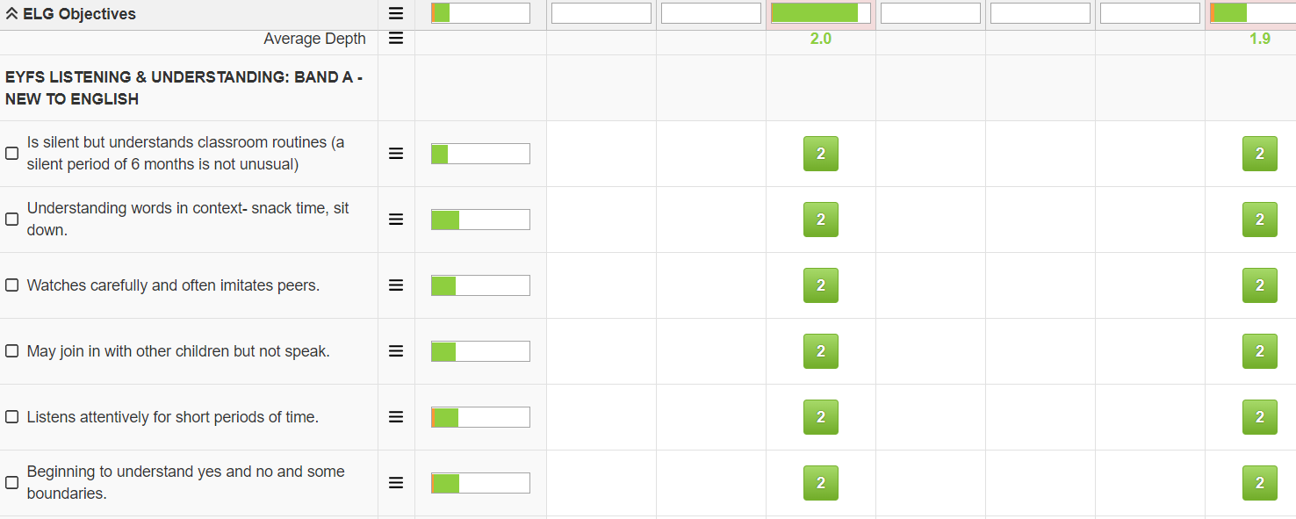

The LPAs we use at Round Hill were adapted from [The Bell Foundation’s](https://www.bell-foundation.org.uk/eal-programme/eal-assessment-framework/) EAL assessment framework and then made age specific (EYFS, KS1 and KS2). In EYFS the assessments areas have been developed in line with the [Statutory framework for the Early Years Foundation Stage](https://assets.publishing.service.gov.uk/government/uploads/system/uploads/attachment_data/file/974907/EYFS_framework_-_March_2021.pdf). These include: listening and understanding, speaking, personal independence, social and emotional skills development and literacy skills. In KS1 and KS2 these are speaking and listening, reading and viewing and writing.

The LPA’s help teachers to identify the language proficiency band that the child is working within. See the bands below:

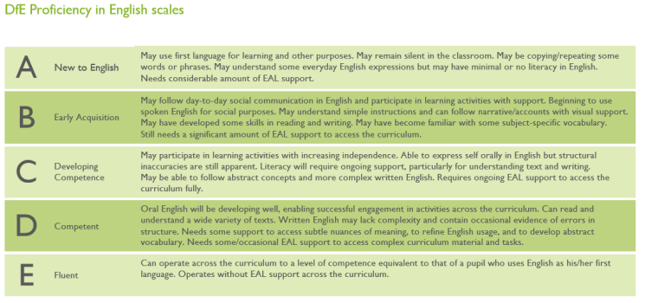

**Resources**

The new library area in school has a range of Equality, Diversity and Inclusion texts for children and staff to read and enjoy. These include many bilingual texts and specific language dictionaries.

There are many books, paper resources which can be photocopied and multicultural resources on the shelves past the head teacher’s office and on the way to the front room. These can be accessed at any time and borrowed by the teaching staff.

Our online shared EAL area has many digital resources for staff to use in supporting and working with EAL pupils. These resources include:

* initial language assessments
* assessment information
* all staff training materials
* notes taken from EAL network meetings
* bilingual resources
* EAL research
* language resources
* information about Young Interpreters/Equality Diversity and Inclusion (EDI) champions club
* a range of diversity books which can be shared on the interactive whiteboard

This can be found at the following pathway:



Further guidance can also be found with this [‘EAL – Need to know’](https://www.em-edsupport.org.uk/Pages/Download/3bc0d5b9-4b55-4225-94f0-5dba5794bb0e/PageSectionDocuments) document and the [‘EAL resources list’](https://www.em-edsupport.org.uk/Pages/Download/7cfc5ae2-dab1-4b0c-80e8-924c80fe5297/PageSectionDocuments) both produced by the Nottinghamshire Achievement and Equality team.

**Equality, Diversity and Inclusion (EDI) champions (formerly Young Interpreters club)**

This year we are looking to continue the award-winning Young Interpreter Scheme at Round Hill that we started last year. The children will now be referred to as EDI Champions to reflect the breadth of their role in school. The EDI Champions role is available to all children in Years 1 to 6.

The role of an EDI Champion is to be a peer-mentor for pupils who are new to English or new to school. It is a high profile responsibility for which training will be provided. This training is with a view to acknowledge and develop pupils’ existing interpreting and communication skills and to allow them to explore how they can help

children settle in to Round Hill. An EDI champion may do the following:

* support socially during break and lunch times e.g. play games
* have their lunch with their buddy
* give tours of the school
* check new arrivals are settling into the school
* check how they are feeling
* demonstrate routines
* help buddies become familiar with clubs and other school activities
* help a pupil to communicate a problem
* become empathetic buddies

At the end of their training, the children are awarded with a lanyard and certificate. The EDI champions club runs every Friday lunchtime to guide them in their role. It is important that the EDI champions are used appropriately around the school – that is as buddies, not replacements for professional interpreters or bilingual staff.

Please see this useful video with more information about the scheme attached:

<https://www.youtube.com/watch?v=AAh5NvYhnA8>

**Roles and Responsibilities**

We believe that promoting EAL and supporting pupils and families is the whole school’s responsibility.

| **School Community** | **Responsibility** |
| --- | --- |
| **Staff involved in admissions (office, SLT member and teaching staff)** | To obtain, collate and distribute information on new pupils to relevant teacher. This includes:  • Language(s) spoken at home;  • From the previous school, information on level of English studied/used;  • Details of curriculum at previous school.  See further information about the mid-phase admissions process below. |
| **Governing Body** | Involve and engage the whole school community in identifying and understanding equality barriers and in the setting of objectives to address these.  Monitor progress towards achieving equality objectives.  Publish data and publish equality objectives.  Ensure that staff have access to appropriate training and resources. |
| **Head Teacher** | As above including:  Promote key messages to staff, parents, and pupils about equality and what is expected of them and can be expected from the school in carrying out its day-to-day duties.  Ensure that all in the school community receive adequate training to meet the need of delivering equality, including pupil awareness.  Ensure that all staff are aware of their responsibility to record, report and respond appropriately to prejudice-related incidents particularly on our safeguarding software CPOMS.  Monitor the progress of EAL learners during pupil progress meetings.  Provide feedback to staff on best EAL practise after lesson observations. |
| **Senior Management Team** | Monitor the progress of EAL learners during pupil progress meetings.  Provide feedback to staff on best EAL practise after lesson observations.  To support the Head as above  Ensure fair treatment and access to services and opportunities.  Ensure that all staff are aware of their responsibility to record, report and respond appropriately to prejudice-related incidents particularly our safeguarding software CPOMS. |
| **EAL Coordinator** | Analyse whole school EAL data. Share findings with staff.  Communciate updates in termly head teachers reports to be reported back to governors.  Attend termly network meetings and communicate updates back to all staff.  Arrange and deliver staff training.  Provide coaching to new members of staff.  Ensure teachers are provided with a termly opporunity to update the EAL LPAs.  Monitor the progress made against the LPAs and provide staff with specific support where relevant. |
| **Teaching Staff** | All involved in teaching EAL learners liaise regularly particularly between assistant teachers and teachers.  Teachers communicate all EAL learners' progress to SLT at end of each-term during pupil progress meetings.  Parents and staff are aware of the school’s policy on pupils with EAL.  Relevant information on pupils with EAL is passed on to all staff.  Training in planning, teaching and assessing EAL learners is accessed.  Challenging targets for pupils learning EAL are set and met.  Are knowledgeable about pupils’ abilities and needs in English and other subjects.  Use this knowledge effectively in curriculum planning, classroom teaching, use of resources and use of resources and pupil grouping.  This is all a part of achieving teachers standard 5 – ‘Adapt teaching to respond to the strengths and needs of all pupils’  ▪ know when and how to differentiate appropriately, using approaches  which enable pupils to be taught effectively  ▪ have a secure understanding of how a range of factors can inhibit  pupils’ ability to learn, and how best to overcome these  ▪ demonstrate an awareness of the physical, social and intellectual  development of children, and know how to adapt teaching to support  pupils’ education at different stages of development  ▪ have a clear understanding of the needs of all pupils, including those  with special educational needs; those of high ability; those with  English as an additional language; those with disabilities; and be able  to use and evaluate distinctive teaching approaches to engage and support them. |
| **Non -Teaching Staff** | Support the school and the governing body in delivering a fair and equitable service to all stakeholders.  Uphold the commitment made by the Head Teacher on how pupils and parents/carers can be expected to be treated.  Support colleagues within the school community.  Record, report and respond appropriately to prejudice-related incidents. We use the safeguarding software CPOMS for this if staff members have access or they would pass this on to be documented by someone with access to this. |
| **Parents/Carers** | Take an active part in identifying barriers for the school community and in informing the governing body of actions that can be taken to eradicate these.  Take an active role in supporting and challenging the school to achieve the commitment given to the school community in tackling inequality and achieving equality of opportunity for all.  Uphold the commitment made by the Head Teacher on how pupils and parents/carers, staff and the wider school community can be expected to be treated. More information is outlined in our [Parent Code of Conduct](https://www.roundhill.notts.sch.uk/attachments/download.asp?file=6457&type=pdf) and the [Home School Agreement](https://www.roundhill.notts.sch.uk/attachments/download.asp?file=378&type=pdf).  Communicate with teaching staff regularly to understand the next steps in their child’s learning and provide some support at home too. |
| **Pupils** | Support the school to achieve the commitment made to tackling inequality.  Uphold the commitment made by the Head Teacher on how pupils and parents/carers, staff and the wider school community can be expected to be treated.  Report prejudice-based incidents to a trusted adult. More information can be found in our [Home School Agreement](https://www.roundhill.notts.sch.uk/attachments/download.asp?file=378&type=pdf). |
| **Local Community Members** | Take an active part in identifying barriers for the school community and in informing the governing body of actions that can be taken to eradicate these  Take an active role in supporting and challenging the school to achieve the commitment made to the school community in tackling inequality and achieving equality of opportunity for all. |

We will ensure that the whole school community is aware of the EAL policy on the school website [insert link].

**Mid-Phase Admissions Policy**

**Procedure**

1. After completing the Local Authority admissions procedure and a child has been accepted for a place at Round Hill the office staff with follow the separate flow-diagram procedures (please see below on page 4).
2. The new parents will have an initial meeting and tour of the school with a member of the SLT. Round Hill parent interpreters are available to communicate with the new family in their first language if the family has little or no English. Our Round Hill Young Interpreters are also available to conduct the initial tour around the school with the new family and preferably the Young Interpreter will be chosen who speaks the family’s first language. Please see the list of parent interpreters and Young Interpreters and the list of languages that they speak who would happily support with this in the purple folder kept in the school office.
3. During the initial meeting the member of SLT will complete the ‘Mid-Phase EAL New Arrivals Form’ (please see below for an example of this on page 6). This includes details about the families contact details, intended length of stay at the school, educational history, any additional needs, family details and the language spoken, read and written by the child. A copy of this will be kept in the child’s file in the school office and another copy will be passed on to the child’s new class teacher.
4. The family will be given the Round Hill’s confidential details form to be returned to the school office and an ‘All About Me’ booklet in the child’s first language to complete and return to their teacher. Please see the purple file for these kept in the school office.
5. Only when the documentation has been fully completed will the Head teacher, in discussion with the other appropriate phase leader or other staff, allocate the child to their new class and inform the class teacher. As part of the decision they will take into account the current balance of the classes and where possible allowing the pairing of children with another child who speaks their home language.
6. The class teacher and other relevant staff e.g. SENCO, medical needs TA, phase leader or the EAL co-ordinator will arrange a meeting with the new child and their parents to welcome them and discuss the child’s individual requirements.
7. Following the meeting, the class teacher in consultation with other relevant staff will make arrangements for the child to be inducted into school. This will include completing the New Arrival Teacher Checklist (please see this on page 5).Ideally, there will be a phased start within one week. When additional preparation is required the phased start may take longer.

**Phased Start**

The child will make a short visit to their class, possibly with a parent, for a part or full half day at the discretion of the class teacher. The purpose of this first visit is to make the child feel welcomed by their new class and teacher. This will take place after the class teacher has prepared a suitable PHSE lesson to welcome the new child.

Following the child’s short welcome visit, the class teacher will arrange for the child to begin regular attendance. This will be at the discretion of the school and may initially include further half day visits before continuous full time attendance begins.

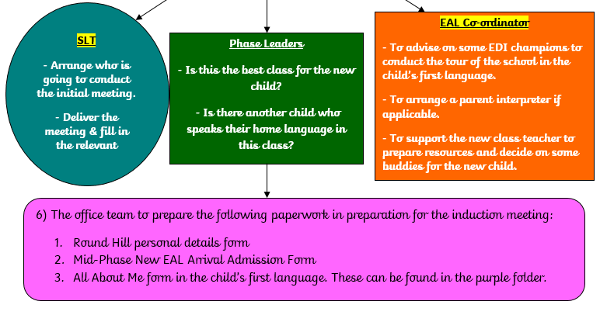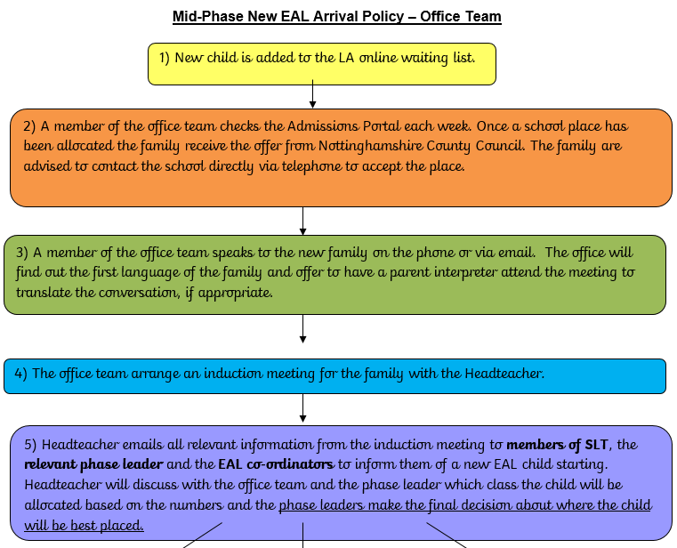

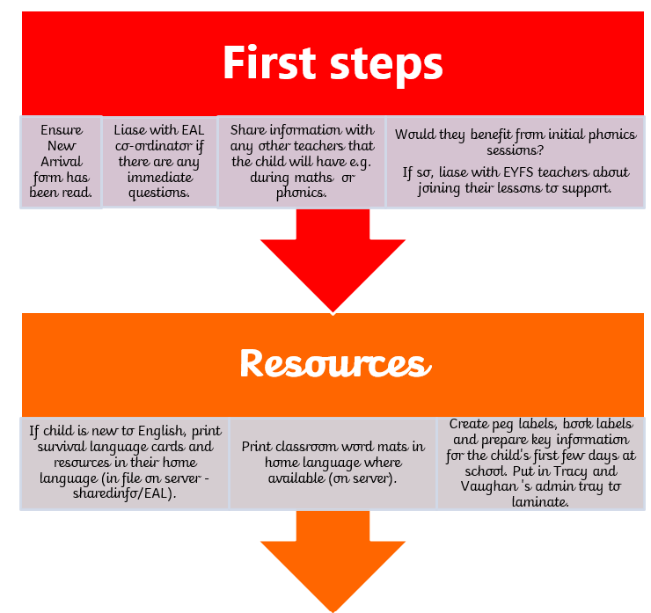

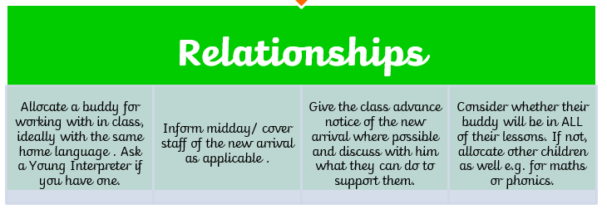

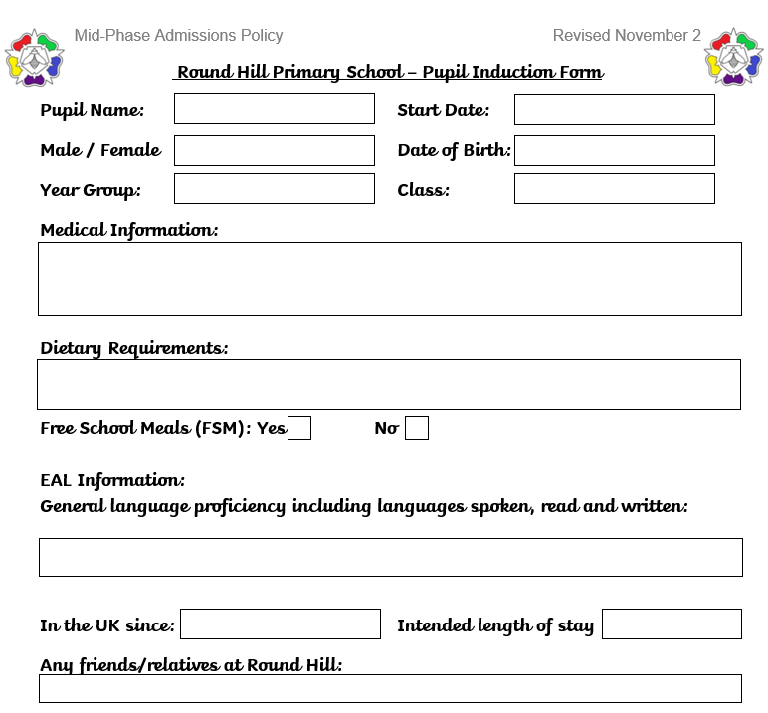

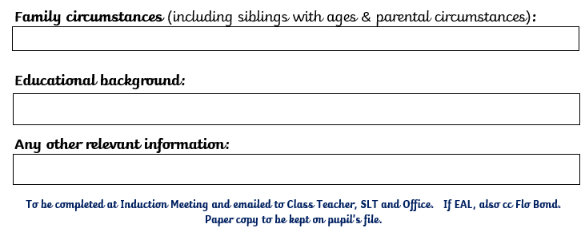

**Links with other policies**

|  |  |
| --- | --- |
| **Policy** | **How it may link** |
| Equality Policy | Our Equality Policy at Round Hill Primary School outlines our duties under the Equality Act 2010. This includes to:  • eliminate discrimination,  • advance equality of opportunity  • foster good relations  We understand the principal of the act and the work needed to ensure that those with protected characteristics are not discriminated against and are given equality of opportunity. |

**Monitor and Review**

As a minimum, we will review this policy annually.

Date Approved by the Governing Body **[Insert date here]**

Date to be reviewed by the Governing Body **[Insert date here]**